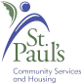**Walk**

For Physical Activity

And Neighborhood Safety

**Learn How to Recognize Things**

**Affecting the Safety of Your Neighborhood**

**What is in it for YOU?**

* + Walking promotes overall health.
  + Walking groups can act as eyes of the community thus discouraging unlawful activities.

**Date & Time: September 17, Wednesday, 10:00am – 11:30pm**

**Assembly:** St. Paul’s L’Amoreaux Centre – Front Desk

3333 Finch Ave E

**Reminders:**

* Wear appropriate clothing and shoes.
* Bring a bottle of water.

**For more information:** Call 416 493 3333

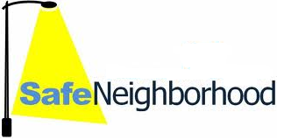**Everyone is Welcome.**

_________________________________________________________________

**步行活動**

為體能運動及鄰社間的安全為主

**認識如何辨別影響您鄰近社區安全的事物**

**這項活動對您有何用?**

* + 步行能提升整體健康。
  + 步行小組能夠起著審視社區的作用，從而防止非法活動的產生。

**日期 及時間︰9月17日 (**星期三**) 早上10:00 – 中午11:30**

**集合地點︰** 早上10:10 於聖保羅中心 – 服務臺

3333 Finch Ave E (Finch 夾 Warden西南角)

**提示︰**  穿著適當衣服及鞋。

帶備一瓶飲用水。

**查詢詳情︰請致電** 416 493 3333

**歡迎任何人士參加**