logo_20061000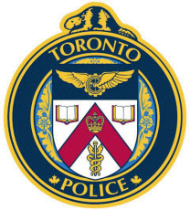**Safe Winter Driving**

**Friday, Nov 20**

**1:30pm – 3:00p.m.**

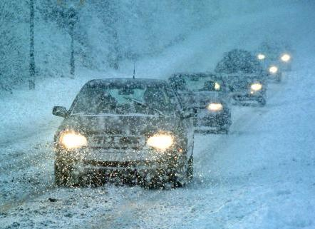

**42 Division**

**Language:** English with Cantonese Interpretation

**Find Out About:**

* How to properly prepare ourselves and our vehicles for winter driving?
* How to find out more about Ontario road conditions before you travel?
* How Ontario manages the snow removal process and when you can expect roads to be cleared?
* What are the benefits of using winter or hybrid tires and how to properly maintain the tires?

**Speaker: Lisa Thompson**

Road Safety Marketing Office, Ministry of Transportation

**Place:** St. Paul’s L’Amoreaux Centre - Recreation Room

3333 Finch Avenue E (southwest corner of Finch and Warden)

**For more information:** Call 416 – 493 – 3333

**Offered by:**

* St. Paul’s L’Amoreaux Centre
* S.A.L.T. (**S**eniors **A**nd **L**aw enforcement **T**ogether)
* Ministry of Transportation

**All are welcome especially seniors, caregivers & service providers!!**



Ministry of Transportation

Government of Ontario