A free six-week program
on Self-Management for
People with Chronic Pain

Learn About:
- Effective ways to deal with chronic pain, fatigue and depression
- Setting up exercise and healthy eating plans
- Ways to feel better and do more of the activities you enjoy
- Strategies for better managing your medication and communicating with your doctor

Dates: March 17, 24, 31, April 7, 14 & 21 (Mondays)

Time: 10:00am – 12:30pm

Location: St. Paul’s L’Amoreaux Centre – Seminar Room C
3333 Finch Avenue East
(Southwest corner of Finch and Warden)

Older adults, seniors with chronic pain, and caregivers are welcome to attend.

Participants will receive a free copy of the book Living a Healthy Life with Chronic Conditions and Participant’s Workbook.

Pre- registration is required on or before March 14, 2013.
To register, please call (416) 493 - 3333 extension 227.


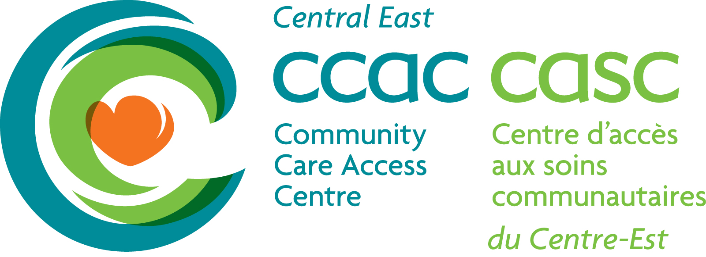

“Living a Healthy Life
with Chronic Conditions”

For more information about this program:
E-mail: elsa@splc.ca
Phone: (416) 493 -3333 ext. 227

